**Parallel Programming Exercise HW01(C)-0608**

|  |  |
| --- | --- |
| **Author:** | 朱紹勳( [b06501018@ntu.edu.tw](mailto:b06501018@ntu.edu.tw)) |
| **Student ID** | b06501018 |
| **Department** | Engineering Science and Ocean Engineering |

(If you and your team member contribute equally, you can use (co-first author), after each name.)

# Problem and Proposed Approach

$$T=λ+\frac{n}{β} , when n=0, T=latency, then β= \frac{n}{T-λ}$$

# Theoretical Analysis Model

# Performance Benchmark

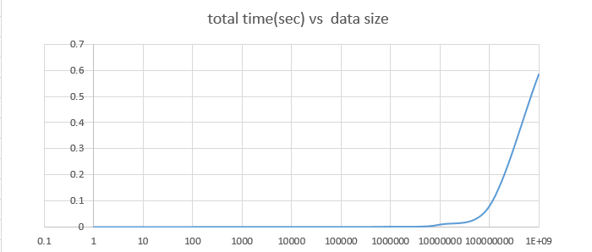

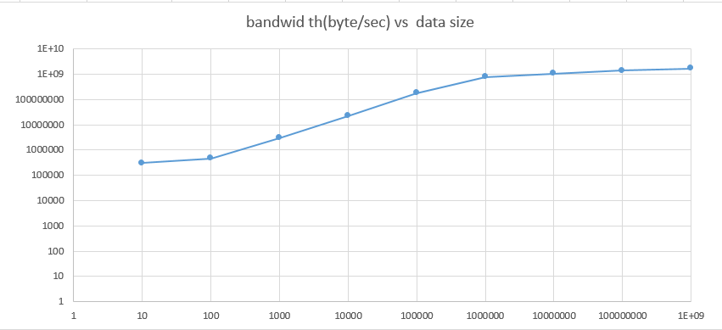

# Conclusion and Discussion

**Appendix(optional):**

(If something else you want to append in this file, like picture of life game)

